**COURIER MANAGEMENT SYSTEM**

*A Project Report submitted for partial fulfillment of the requirements for the 3rd* semester of

**Masters of Computer Application (MCA) of**

**JORHAT ENGINEERING COLLEGE**

**UNDER ASSAM SCIENCE AND TECHNOLOGY UNIVERSITY**



### Submitted by:

Gourab Gogoi

(Roll No.: 210720043013)

Jyotim Kashyap

(Roll No.: 210720043018)

MCA 3rd Semester

Jorhat Engineering College, Assam

Under the Guidance of

Mr. Abinash Borah

**DEPARTMENT**

**Of**

**COMPUTER APPLICATION**

**JORHAT ENGINEERING COLLEGE**

**JORHAT, ASSAM**

CERTIFICATE

This is to certify that the project entitled “**COURIER MANAGEMENT SYSTEM**” submitted **by GOURAB GOGOI (Roll No. 210720043013)** and **JYOTIM KASHYAP (Roll No. 210720043018)** in partial fulfilment of requirements for the 3rd Semester project of Masters of Computer Application (MCA) of Jorhat Engineering College, under Assam Science and Technology University has been examined.

….…………………………… …………..………………

Signature of the Guide Signature of the HOD

Mr. Abinash Borah (Dr.Siddhartha Baruah)

Department Of Computer Application HOD,Department of Computer Application

**Jorhat Engineering College Jorhat Engineering College**

ACKNOWLEDGEMENT

We take this opportunity to express our profound gratitude and deep regards to our guide **Mr. Abinash Borah** (Assistant Professor, Computer Application Department, JEC) for his exemplary guidance, monitoring and constant encouragement throughout the course of this project. The blessing, help and guidance given by him time to time will carry us a long way in the journey of life on which we are about to embark.

We also take this opportunity to express a deep sense of gratitude to HOD, Computer Application Department, JEC for his cordial support, valuable information and guidance which helped us in completing this task through various stages.

Lastly, we thank the almighty, our parents and our classmates for their constant encouragement without which this project would not have been possible.

Place: - Jorhat

Jyotim kashyap (Roll No: **210720043018**)

Gourab Gogoi (Roll No: **210720043013**)

MCA (3 rd Semester)

Jorhat Engineering College, Assam

# Abstract

The COURIER MANAGEMENT SYSTEM is a web based system that’ designed primarily for the use in the couriers logistics industry this system will allow courier and logistical services company to increase scope of the business by reducing the paper work cost and accountability of goods involved this system also allows quick and easy management of transporting parcels from one point to another as they can be easily tracked compared to the use of manual systems of recording information as it includes message sent to the receiver and the sender to track the parcel .courier services employees use the system through an easy to navigate graphical interface for efficient processing. While taking orders from its customers, it will take all the details of its customers who is placing the orders and all the details for the recipient such as its address,name,mobile number.

**Keywords:** Courier Management System ,php, Laravel, html, Css, Bootstrap, MySql.

.

**CONTENTS**

Introduction 6

Aim and objective 7

Feasibility Study 8

Requirements Gathering and Analysis 9

System Study 10

System implementation 11

Module Description 12

Entity Relationship (ER) Diagram 13

Data Flow Diagram(DFD) 14

Snapshots 16

Conclusion………………………………………………………………………20

# INTRODUCTION

The project emphasizes the planning and execution of delivery of packages and goods by using a Courier Management System. The system maintains details about the branches of the company, parcels/packages placed, delivery status of the parcels. The system is used for daily activities such as placing orders, loading them, delivery status checking and managing the branches and more. To avoid paper work. Hence it is recommended to computerize the process by developing the relative software as the world is turning into information and technology. By doing so, the task of handling the parcels will get easier, quicker and also more efficient.

The Courier Management System proposed here avoids spending more manual hours in maintaining records and generating reports. Daily transactions are managed easily and the centralized database helps in avoiding conflicts between different branches and placing orders in a large scale. It avoids human errors in feeding parcel details or handling records, and provides support to customers by enabling them to track the status of their parcels.

**AIM AND OBJECTIVE**

**AIM:** To develop an interactive web application which places, updates and tracks the delivery status of packages with customer-friendly query support.

**OBJECTIVE:**

* Develop cost efficient solution system.
* Develop a user friendly interface
* Delivery status tracking for the customers.
* Placing new package, updating the status of the existing packages.

# FEASIBILITY STUDY

It is necessary and prudent to evaluate the feasibility of a project at the earliest possible time. There may be different ways of checking whether a system is feasible or not. The following feasibility studies were performed to gauge the feasibility of the system.

**OPERATIONAL FEASIBILITY**

In this test, the operational scope of the system is checked. The system under consideration should have enough operational reach. It is observed that the proposed system is very user friendly and since the system is built with enough help, even persons with little knowledge of websites can find the system very easy.

**TECHNICAL FEASIBILITY**

This test includes a study of function, performance and constraints that may affect the ability to achieve an acceptable system. This test begins with an assessment of the technical viability of the proposed system. The management provides latest hardware and software facilities for the successful use of the system. With these latest hardware and software support the system will perform extremely well. The system is available through Internet.

**ECONOMIC FEASIBILITY**

The development cost of the system is evaluated weighing it against the ultimate benefit derived from the new system. It is found that the benefit, from the new system would be more than the cost and time involved in its development.

Intangible cost and benefits: -

* Easy to use, simple and user friendly
* Less usage of papers
* Save allowance for losing and buying tools and equipment.

# REQUIREMENTS GATHERING AND ANALYSIS

We set our first set of context-free questions that focuses on the users’ requirements, overall project goals and benefits. The questions are:

1. How long will the project timeline be?
2. Who will be using the project outcomes?
3. Who will make the decision about the project?
4. Who will provide the resources to fulfil the project?
5. Whose work will affect the project?

These questions helped us to identify the measurable benefit of the successful implementation and possible alternatives to develop the application.

We finalized the following requirements for the system by categorizing and prioritizing the requirements:

1. Web-based application for user.
2. Accessible via the internet.
3. Allow user to login, manage the system and logout.
4. Maintain a database for the service.

**Requirements to develop the website:**

1. Processor: Intel Pentium (1.2GHz or above).
2. Internal Storage: - 40GB or above.
3. **RAM: 1 GB or above.**

**Requirements to run the website:**

1. Any computer or mobile device
2. An internet connection.
3. Operating System: Windows 7 or above.
4. An Internet Browser (Google Chrome is preferable).

# SYSTEM STUDY

The proposed system is implemented to replace the manual system involving a lot of paperwork.

* + **Existing system:** The existing system is more prone to human error in terms of assigning mistake. The paper-based system is more prone to human error with data throughout the manual system. Often information is incomplete, or does not follow management standards. Records are often lost in transit requiring a comprehensive auditing process to ensure that no vital information is lost. Also, there is a probability of calculation errors during the process.
  + **Proposed system** This system designed to replace the existing manual paper-based system. The new system is to control the following information: records of Track Parcel details,add user,add branch, etc. These services are to be provided in an efficient, effective manner, with the goal of reducing the time and resources currently required for such tasks. The proposed system is fully responsive so the user is able to use it in any devices such as laptops or mobile.

# 

# SYSTEM IMPLEMENTATION

**Tools/Technologies and Languages used for development:**

|  |  |
| --- | --- |
| Language used | Software used |
| SQL, php, Laravel, html, | * VS Code,Postman |

**System requirements:**

The hardware required for this software is a personal computer (desktop or laptop) with the minimum hardware configuration given below:

* + Operating system: Windows (7/8/10/11), Linux (all current major distributions)
  + Processor: Intel pentium
  + Browser: Any Chromium-based browser (Google Chrome, Microsoft Edge, etc.)
  + RAM:1GB

# MODULE DESCRIPTION

The user interface of this interactive web application is developed using oracle apex, pl/sql is the standard mark-up language for documents designed to be displayed in a web browser.

**Login-** Admin can place order/update/delete.

**Member -** Can add members as either admin or staff.

**Branch -** Can add branch.

**Parcel -** Send parcels, update status, edit parcel.

**Track -** Can track status of the parcels.

**Log-Out-** On clicking this button the user who is currently logged in will be removed from the current login session and will be redirected to the login page.

# ENTITY RELATIONSHIP (ER) DIAGRAM

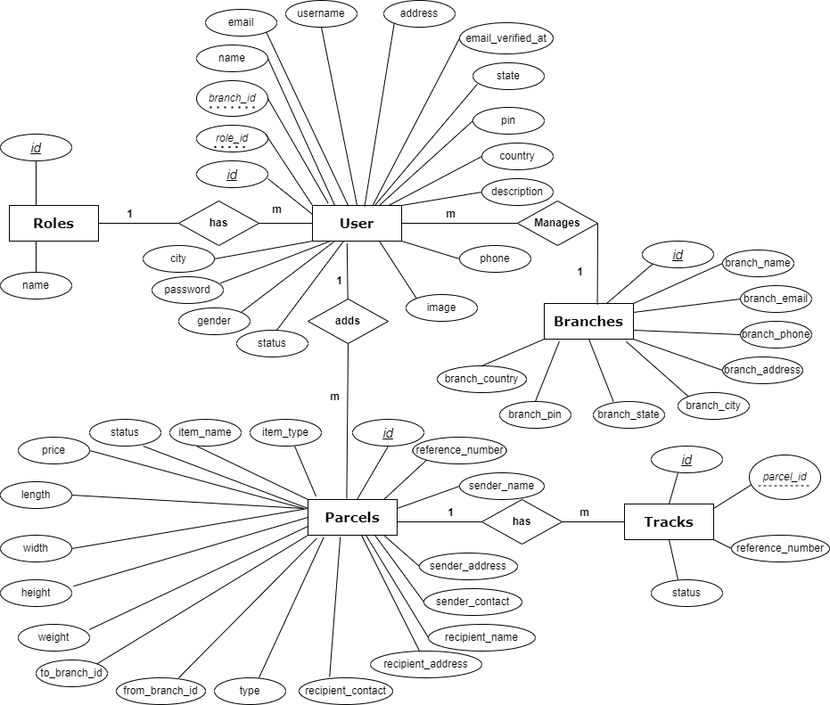

# DATA FLOW DIAGRAM (DFD)

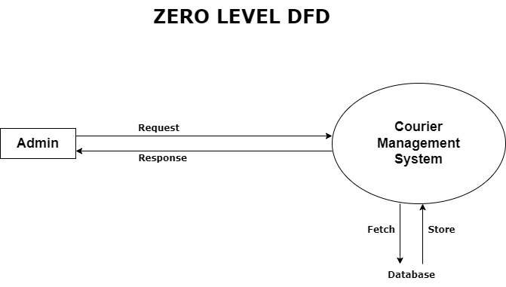

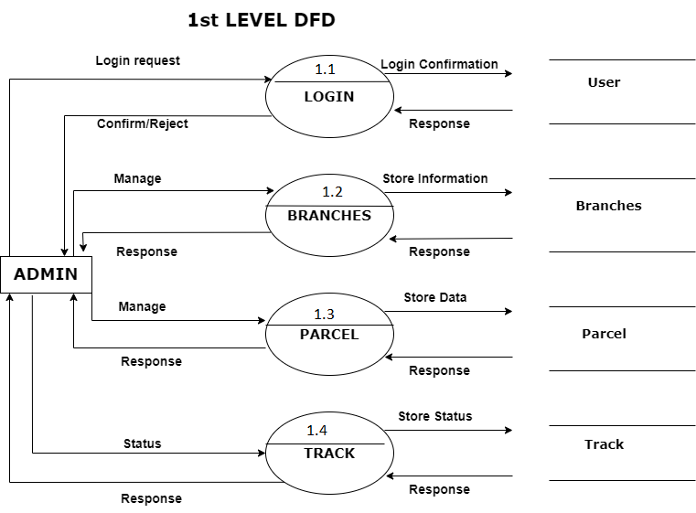

# SNAPSHOTS

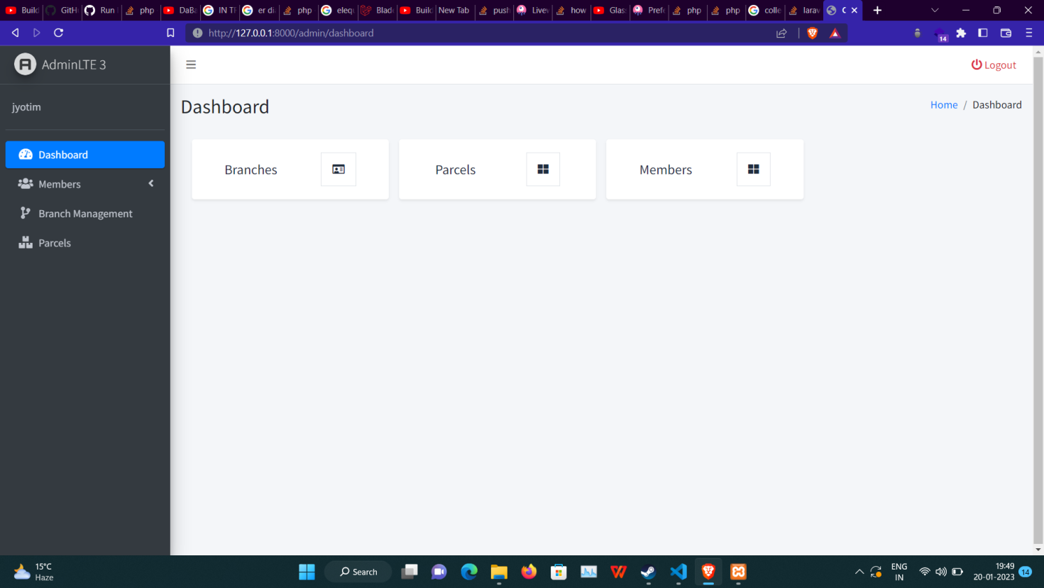

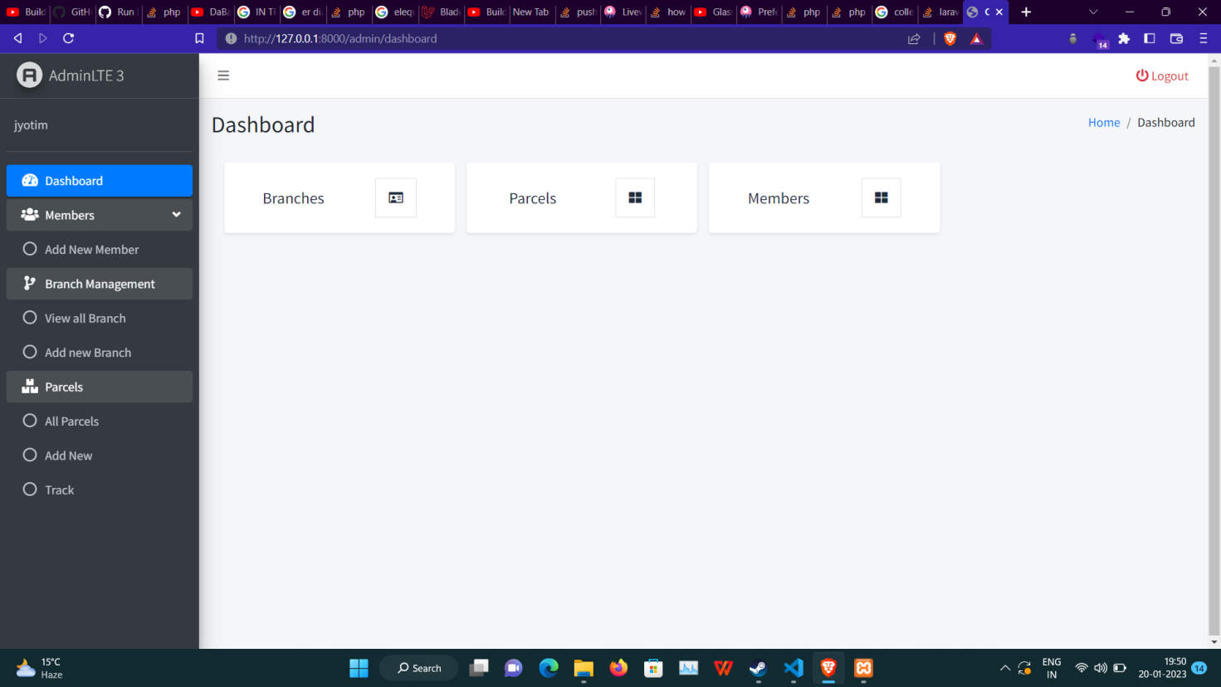

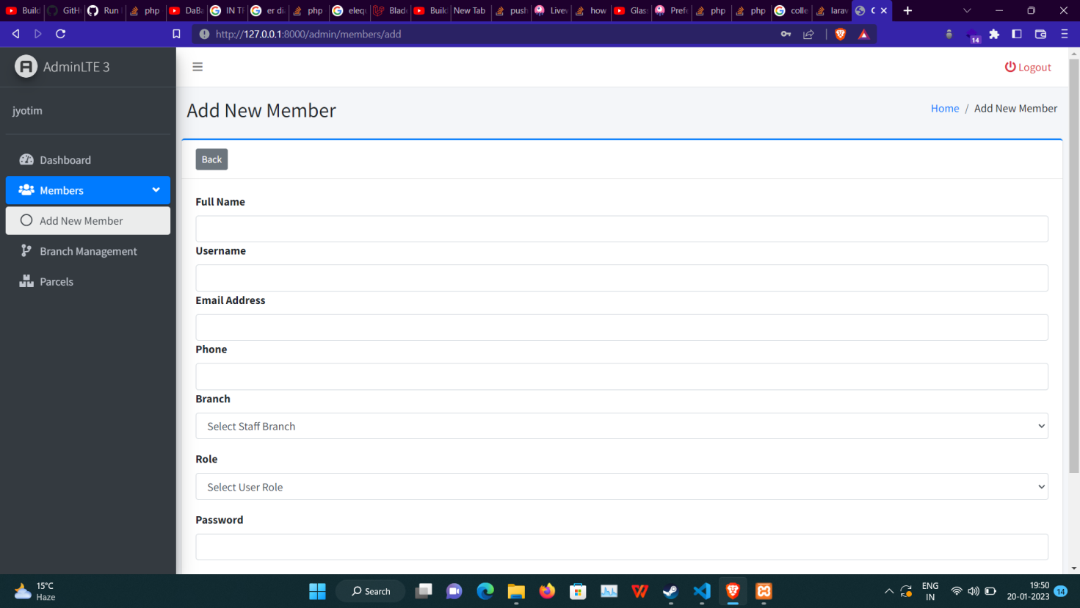

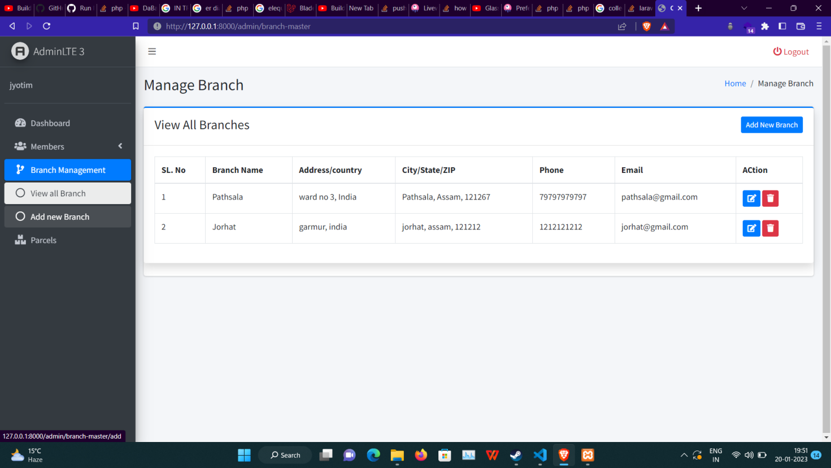

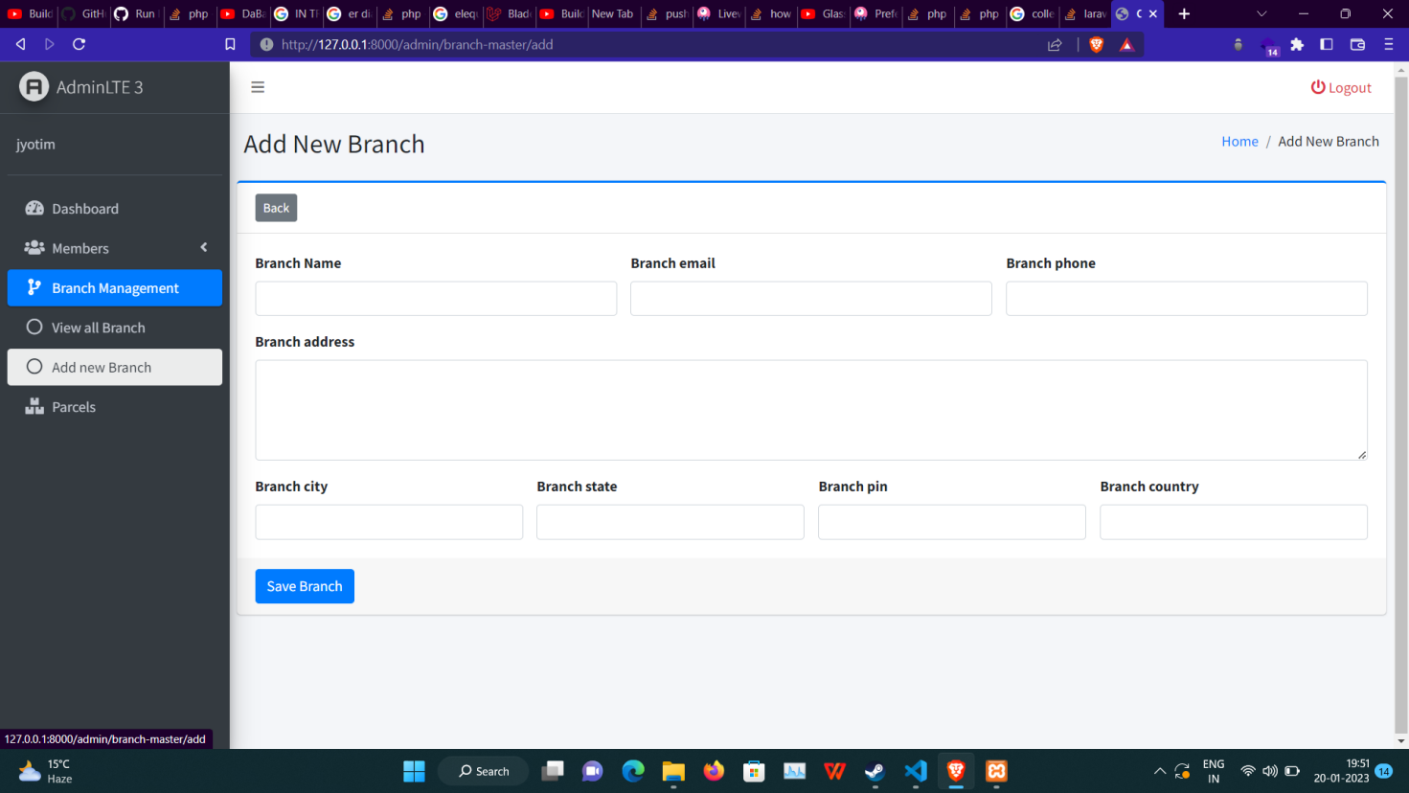

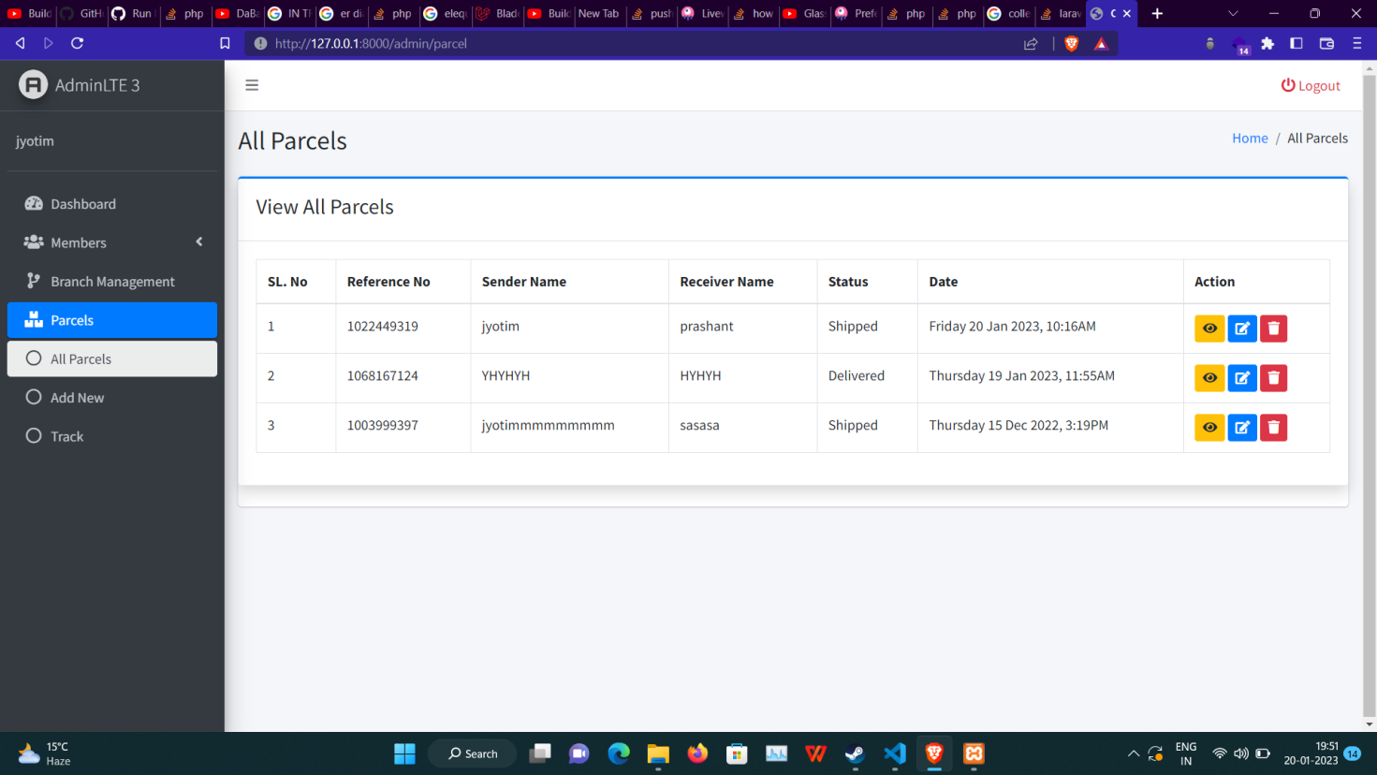

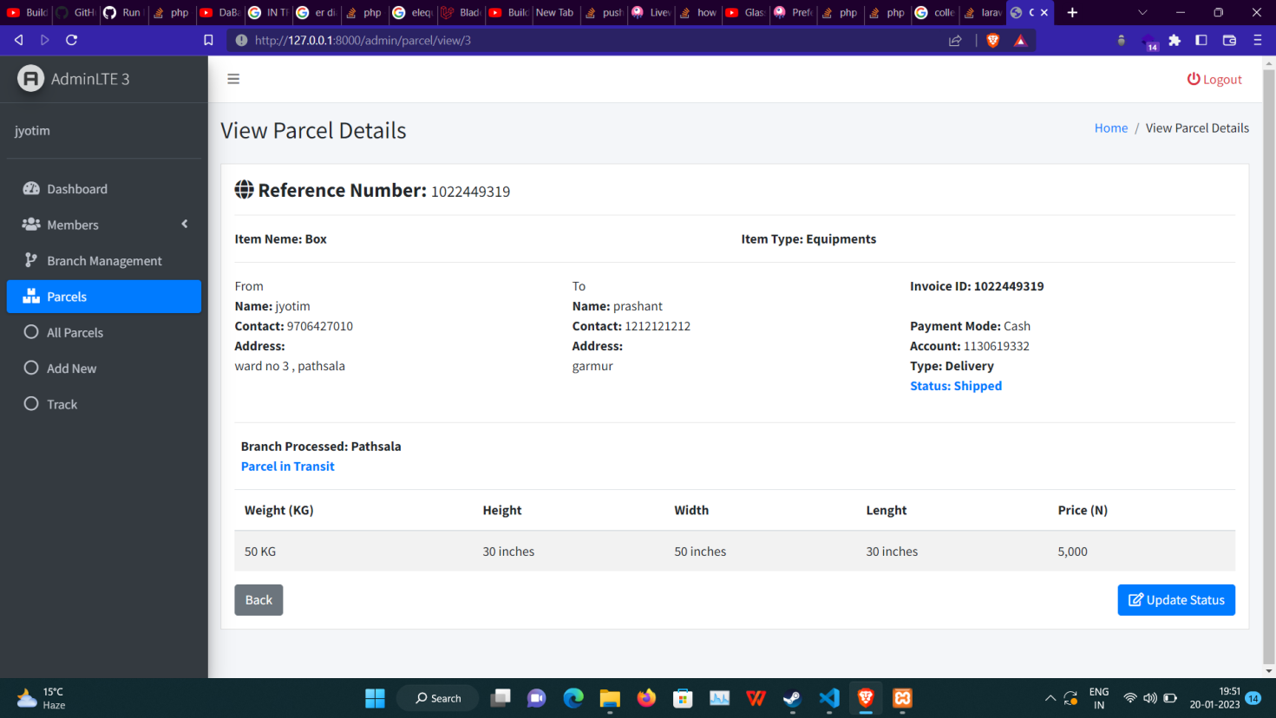

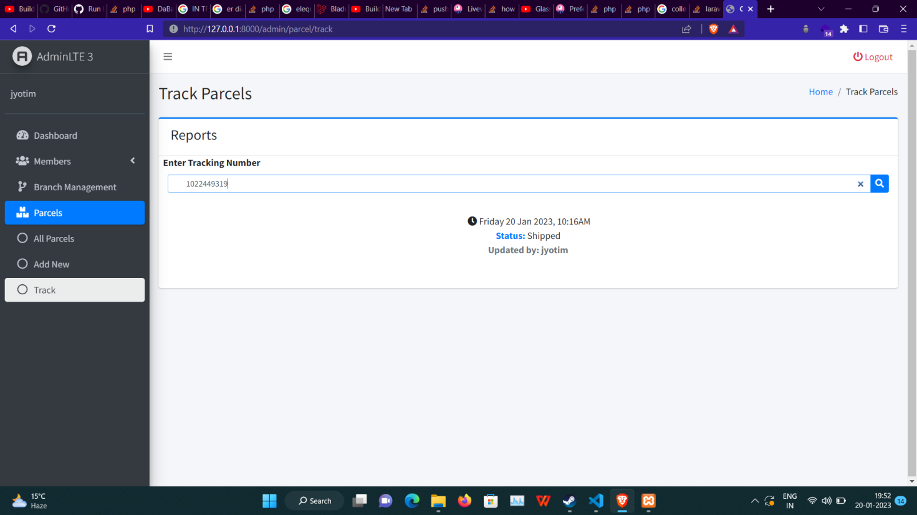

# CONCLUSION

To summarize, the world is rapidly evolving and heading toward technical expertise. Technology is not a static or stagnant field, but rather one that is constantly changing as new trends arise. As patterns change and improve, it's past time for us to change with them. The use of courier management systems is important for getting accountability and making goods get delivered quickly and making the work easier.

As a premium service, couriers are usually more expensive than standard mail services, and their use is typically restricted to packages where one or more of these features are considered important enough to warrant the cost.  It is a modern way of usage to a Courier Service through a computer system.